**Python Class - 6**

1.Write a Python program to read a file line by line and store it into a list.

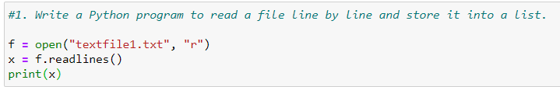

2. Write a Python program to read a file line by line store it into an array.

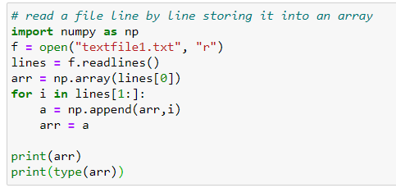

3. Write a Python program to read a random line from a file.

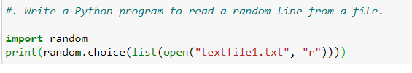

4. Write a Python program to combine each line from first file with the

corresponding line in second file

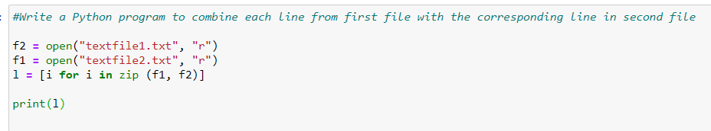

5. Write a Python program to generate 26 text files named A.txt, B.txt, and

so on up to Z.txt.

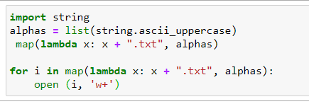

6. Write a Python program to create a file where all letters of English alphabet are listed by specified number of letters on each line.

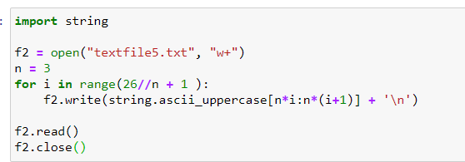

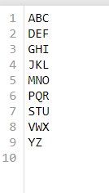

7. - To scrap data from worldometer example: INDIA Data and run it

on live mode.

- Print Additionally total number of Coronavirus

Cases, Deaths, Recovered.

